**Analysis of FDM parameters of PLA/CFRP composites for the mechanical properties by design of experiment**

M.P.Jenarthanan1, Surya Y1, Abdul Basit1 and M.Karthikeyan1⁕

1 SASTRA Deemed to be University, Thanjavur 613401  
jenarthanan@mech.sastra.edu, ysuryachola@gmail.com,11.abbasit@gmail.com and ⁕karthikeyan@mech.sastra.edu

**Abstract.** In this research, the optimal combination of process parameters of Fusion Deposition Modelling (FDM)/3D printing are determined based on mechanical properties such as tensile and hardness of Polylactic acid (PLA)/Carbon fibre composites (CF-PLA). The experiments are designed based on Response Surface Methodology. Central Composite Design of L13 with 2 factors (speed and infill %), 3 level Design of Experiment (DoE) has been implemented for the box type resin deposition pattern, The interaction effect of the input process parameters factors has been analysed by solving the regression equation and the response surface plots. The significant levels and parameters have been identified using Analysis of Variance (ANOVA). The second order response surface model showed the optimal combination of input parameters for the higher tensile strength and hardness.

## INTRODUCTION

In recent times, several PLA-based technologies have emerged with an emphasis on achieving chemical, mechanical and biological properties equivalent or superior to conventional polymers. The frequent need for a chemical or physical modiﬁcation of PLA to achieve suitable properties for it intended consumer and biomedical applications has demanded signiﬁcant attention in the last decade.

Zhaobing *et al* (2019) investigated the mechanical characteristics of samples fabricated by FDM with different additives, i.e. wood, ceramic, and copper, aluminum and carbon fiber, based PLA composites are comprehensively investigated. The effects of different PLA composites, build orientations and raster angles on mechanical responses were compared and analyzed. Xin *et al* (2017) reviewed on 3D printing techniques of polymer composite materials and the properties and performance of 3D printed composite parts as well as their potential applications in the fields of biomedical, electronics and aerospace engineering. Common 3D printing techniques such as FDM, SLS, inkjet 3D printing, STL, and 3D plotting were reviewed. The formation methodology and the performance of particle-, fiber- and nanomaterial-reinforced polymer composites were emphasized.

Javeed (2016) discussed the 3D printing applications for ecological monitoring and sample collection is discussed. The application was summarized in hydrodynamics, biomechanics, locomotion tangible coral props and coral reef restoration. Mary *et al* (2016) presented the major opportunities, constraints, and economic considerations for Design for Additive Manufacturing (AM). They explored the issues related to design and redesign for direct and indirect AM production. They also highlighted key industrial applications, and outlined future challenges.

Zengguang *et al* (2019) overviewed in the interface bonding property, mechanical properties, and shape precision promotion of FDM 3D-printed PLA parts as well as the functional expansion of the PLA parts. Vladimir *et al* (2018) studied the influence of geometrical parameters of FDM-fused filament fabrication 3D printing process on printed part strength for open source desktop 3D printers. The study was conducted using a set of different nozzles size and arrangement of layer heights from the minimum to maximum physical limits of the machine. Song *et al* (2017) fabricated dense PLA blocks by 3D-printing, depositing a polymer filament in a single direction via FDM. Specimens were cut from printed blocks using conventional machining and were used to perform tension, compression and fracture experiments along different material directions. The response of the unidirectional, 3D-printed material was compared to that of homogeneous injection-moulded PLA, showing that manufacturing by 3D-printing improves toughness. [John](http://refhub.elsevier.com/S2238-7854(19)30190-5/sbref0035)*et al* (2018) discussed about AM and also the most employed AM technologies for polymers. The commonly-used ASTM and ISO mechanical test standards which have been used by various research groups to test the strength of the 3D-printed parts have been reported.

David *et al* (2017) gathered materials requirements for AM information for the categories of ISO/ASTM AM categories. Polymers, metals, ceramics and composites were considered. Microstructural features affecting AM part properties were listed. Shilpesh and Harshit (2018) studied the tensile strength of the FDM printed PLA part. The effect of process input parameter, namely, raster angle, layer height and raster width, have been studied. Saurabh and Inderdeep (2018) explored fiber surface treatment in order to limit the environmental hazards of conventionally used chemical treatments. Fiber surface modification of Aloe Vera fibers prior to their incorporation into PLA based biocomposites was done using an aqueous solution of sodium bicarbonate

Chacon *et al* (2019) stated that the mechanical performance of 3D printed continuous fibre reinforced thermoplastic composites was studied. Continuous glass, carbon and Kevlar reinforced nylon composites were manufactured by FDM technology. Tensile and three-point bending tests were carried out to determine the mechanical response of the printed specimens Kovan *et al* (2018) used PLA and PLA matrix 15% short carbon fibre reinforced composites. PLA Carbon composites were also observed to have a very low tensile strength in comparison to pure PLA specimens at a layer thickness of 0.2 mm. However, no significant change in the tensile strengths of the PLA Carbon composites at the layer thickness of 0.2 was observed with changing printing orientation angle.

A mathematical model for surface roughness and delamination through RSM was developed by Jenarthanan *et al.* (2012) and Jenarthanan and Jeyapaul (2013) in milling of GFRP and CFRP composites, respectively with solid carbide end mill cutter coated with polycrystalline diamond. Naresh Neeli *et al.* (2018) carried out the experiments as per the Taguchi experimental design and an L27 orthogonal array was used to study the influence of various combinations of process parameters on surface roughness and delamination factor. As a dynamic approach, the multiple response optimization was carried out using RSM and DFA for simultaneous evaluation. These two methods are best suited for multiple criteria evaluation and are also not much complicated.

In the present study, the mechanical properties such as tensile and hardness of CF-PLA composites samples fabricated by 3D Printers are evaluated. Identification of the influence of the operating parameters of 3D printing such as infill % and speed for the box type pattern has been analyzed. The interaction effect of the factors has been obtained by solving the regression equation and the response surface plots. The “Design Expert 12.0” software has been used for the analysis. The significant factors have been identified using ANOVA.

## 2. EXPERIMENTAL PROCEDURE

### 2.1 Materials:

The filaments of virgin PLA (Ingeo4043D, Nature Works LLC) and PLA with different additive powder (carbon fiber) with a diameter of 1.75mm were used as printing materials, which were purchased from Exclametric Technologies, Chennai. The blend ratio of PLA and each additive was chosen as approximately 3:2 in this research, which is believed to have the effectively modified mechanical properties compared to the virgin PLA.

### 2.2 Equipment:

The FDM printer (Model: Creator Pro, Flashforge Co., Ltd., China) was used in this research. The control accuracy of the printer is about ±0.1–0.2 mm. Mechanical properties were tested in a universal testing machine (Model: DNS-100, manufactured by Sino test Equipment Co., Ltd., China) with a load of 100 kN. The samples were loaded up to material failure at a displacement rate of 50 mm/min for tensile test. Hardness was tested in a hardness tester (Model: AI-RAB250, manufactured by AKASH industries) with a load of 160 Kgs.

### 2.3 Test Sample preparation:

To evaluate the mechanical properties, dog-bone shaped parts with box type pattern were fabricated by the FDM printer according to the ASTM D638 standard. The sample was prepared to make sure the obtained values of mechanical properties reliable. The Dimensions of the tested sample are presented in Figure.1. For printing orientation, kind of printing path was designed with raster angles of 0◦where, for instance, 0◦ means the axial direction along the sample length in the corresponding printing orientation, and 90◦ is the transverse direction. The printing path with raster angles follows a similar routine as that of 0◦/90◦does. Key printing parameters adopted in this work is provided in Table 1.

**TABLE 1:** Material Properties

|  |  |
| --- | --- |
| **MATERIAL** | **Carbon fiber-based PLA** |
|  |  |
| Platform temperature | 65◦ C |
| Nozzle temperature | 200◦ C |
| Nozzle diameter | 0.4mm |
| Layer height | 0.3mm |
| Raster angle | 0◦ |

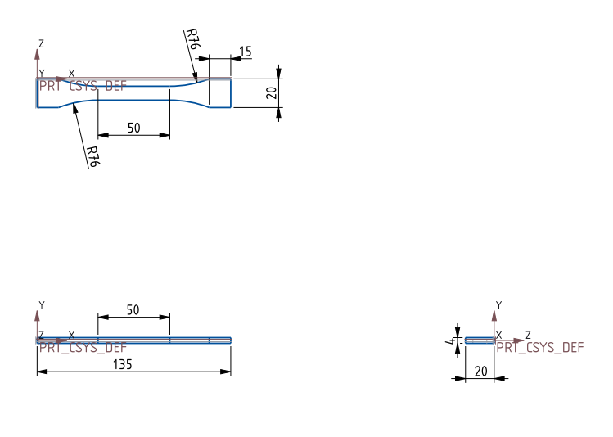



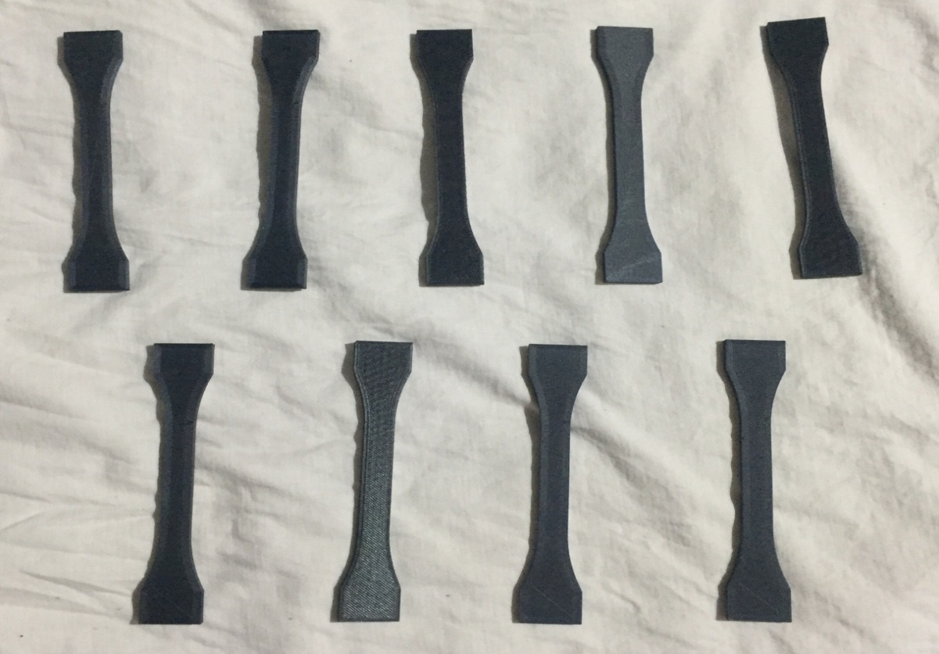

## FIGURE 1: Dimensions of specimen & Test samples

**3. TESTING PROCESS**

### 3.1 Tensile Test:

The stress obtained at the highest applied force is the tensile strength. The Yield Strength is the stress at which a prescribed amount of plastic deformation (commonly 0.2%) is produced. Elongation describes the extent to which the specimen stretched before fracture. Information Concerning the strength, stiffness, and ductility of a material can be obtained from a tensile test. Variations of the tensile testing include; Room Temperature, low Temperature, Elevated Temperature (ASTM E21), Shear, Temperature and Humidity, Combined Tension and Compression, Through Thickness, True Strain, Notched Tensile and r (ASTM E646) & n (ASTM E517) values.

**TABLE 2:** Input Parameters

|  |  |  |  |
| --- | --- | --- | --- |
| **S.No.** | **Infill %** | **Speed Range** | **Structure** |
|  |  |  |  |
| 1 | 10 | Low | Box |
| 2 | 20 | High | Box |
| 3 | 30 | Medium | Box |

**TABLE 3:** Test results of Tensile strength

|  |  |
| --- | --- |
| **Sample no** | **Tensile strength (MPa)** |
|  |  |
| 1 | 27.45 |
| 2 | 24.68 |
| 3 | 35.76 |

### 3.2 Hardness Test:

All hardness tests involve the utilization of a particularly shaped indenter that is harder than the material under testing. The indenter is pressed onto the test surface with the use of a certain amount of force. The size of the depth of the indent is measured to determine the hardness value.

Rockwell & Rockwell Superficial tests consist of forcing an indentor (Diamond or Ball) into the surface of a test piece in two steps i.e. first with preliminary test force and thereafter with additional test force and then measuring the depth of indentation after removal of additional test force (Remaining preliminary test force active) for measurement of hardness value.

## CALCULATIONS

The Rockwell hardness (HR) is calculated by measuring the depth of an indent after an indenter has been forced into the specimen material at a given load.

Scale=B (Red Dial)

Load=160kgs

Indenter = 1/4" ball (mm)

Officially, hardness testing loads are expressed in Newton (N). However, historically, loads were expressed in kilogram-force (kgf), gram-force (gf), or pond (p). The correlation between kgf, kp, and N is

1.0 kgf = 1,000 gf = 1.0 kp = 9.81 N.

**TABLE 4:** Hardness Test Results

|  |  |
| --- | --- |
| **Sample no.** | **Hardness Value (HRB)** |
| 1 | 102 |
| 6 | 135 |
| 8 | 115 |

### 3.3 Test Reports:

Tensile Test Details:

Name of organization: OMEGA lab MMN

Test Method: ASTM D638

The Tensile strength of the specimens are shown in Figure. 2.

Specimen no:8

Thickness : 3.59 mm

Width : 9.92 mm

Area : 35.61 mm2

Infill : 30%

Speed Range : Medium

Structure : Box

Result:

Fmax : 1.27 kN

UTS : 35.76 MPa

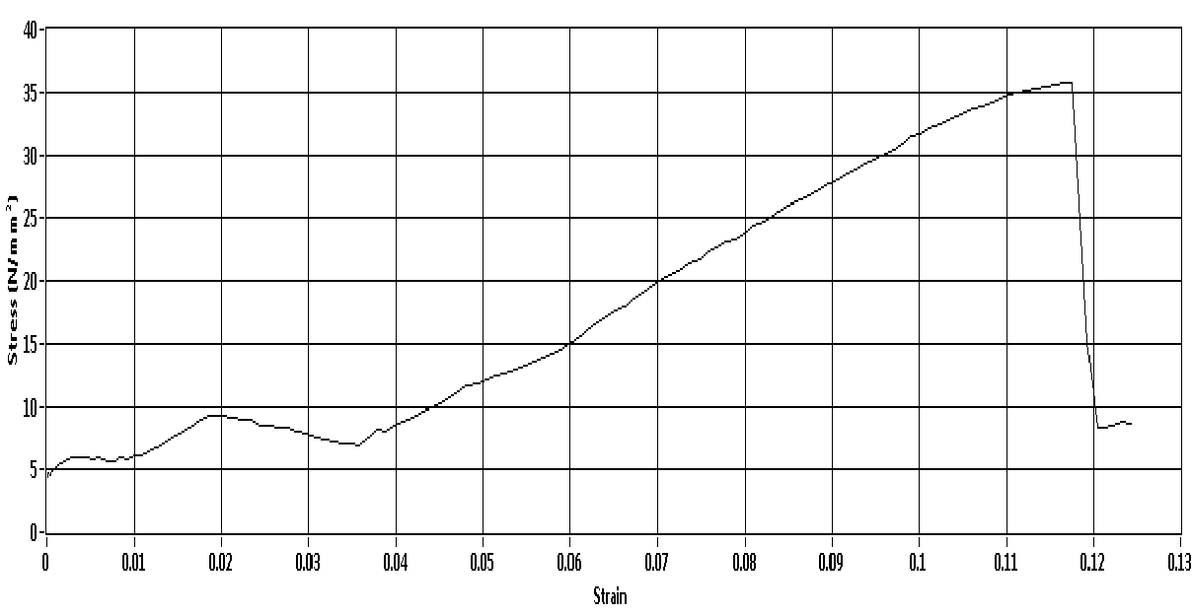

**FIGURE 2:** Tensile graph for specimen no-8

### 3.4. Optimization

RSM is a collection of mathematical and statistical techniques that are useful for modeling and analyzing of problems in which an output or response influenced by several variables and the goal is to find the correlation between response and variables.

If all variables are assumed to be measurable, the response surface can be expressed as follows:

$y=f(x_{1},x_{2}, …x_{k})$ (1)

The goal is to optimize the response variable y. It is assumed that the independent variables are continuous and controllable by experiments with negligible errors. It is required to find a suitable approximation for the true functional relationship between independent variables and the response surface. Usually a second-order model is utilized in RSM:

$y=β_{0}+\sum_{i=1}^{k}{β_{i}x_{i}}+\sum_{i=1}^{k}{β_{ii}x_{i}^{2}}+\sum_{i=1}^{k}{β_{ij }x_{i}x_{j}+ε}$ (2)

Where $ε$ is a random error, β is the coefficients, which should be determined in the second-order model, are obtained by the least square method.

CCD have been found to be the most efficient tool in RSM to establish the mathematical relation of the response surface using smallest possible number of experiments without losing its accuracy. In the present case, size of the experiment is 13 for two process parameters with three levels each.

Table 5. Shows the 13 set of coded conditions used to form the CCD matrix. It comprises of full replication of 23= 8 factorial design plus 5 centre points. All chosen variables at the intermediate level (0) constitute the centre points and the combinations of each of the variables at either it is lowest (-1) or highest (+1).

**TABLE 5:** DoE – L13 Array

|  |  |  |  |  |
| --- | --- | --- | --- | --- |
|  | **Factor 1** | **Factor 2** | **Response 1** | **Response 2** |
| **Run** | **A: Infill** | **B: Speed** | **Tensile** | **Hardness** |
|  | **%** | **mm/min** | **MPa** | **HRB** |
|  |  |  |  |  |
| 1 | 30 | 60 | 28.58 | 129.1 |
| 2 | 30 | 80 | 34.46 | 113.7 |
| 3 | 10 | 60 | 27.54 | 102.3 |
| 4 | 10 | 80 | 29.58 | 132.1 |
| 5 | 20 | 70 | 27.36 | 125.2 |
| 6 | 20 | 70 | 27.36 | 125.2 |
| 7 | 20 | 70 | 27.36 | 125.2 |
| 8 | 20 | 70 | 27.36 | 125.2 |
| 9 | 30 | 70 | 33.38 | 128.6 |
| 10 | 10 | 70 | 30.42 | 124.4 |
| 11 | 20 | 80 | 27.48 | 121.6 |
| 12 | 20 | 70 | 27.36 | 125.2 |

$X_{i}=\frac{[2X-\left(X_{max}+X_{max}\right)]}{[\left(X_{max}-X_{min}/2\right)]}$ (3)

where, Xmax is the upper level of the parameter, Xmin is the lower level of the parameter and Xi is the required coded values of the parameter of any value of X from Xmin to Xmax.

## 4. RESULTS AND DISCUSSIONS

Tensile strength evaluation is very important and used as reference value for many such as stress analysis, fatigue analysis

etc. For this reason, Tensile strength has been the subject of experimental and theoretical investigations for many decades. Tensile strength imposes one of the most critical constraints for the selection of process parameters. The study of tensile strength characteristics of CF-PLA composites depends on many factors, and is more influenced by the process parameters like % of infill, speed, and pattern.

The fit summary recommended that the quadratic model is statistically significant for analysis of tensile strength and hardness. The results of the quadratic model for tensile strength and hardness in the form of ANOVA are given in the Tables 6.

**TABLE 6:** ANOVA for Tensile strength

|  |  |  |  |  |  |  |
| --- | --- | --- | --- | --- | --- | --- |
| **Source** | **Sum of Squares** | **df** | **Mean Square** | **F-value** | **p-value** |  |
| Model | 92.69 | 5 | 18.54 | 27.97 | 0.0002 | significant |
| A-Infill | 12.77 | 1 | 12.77 | 19.26 | 0.0032 |  |
| B-Speed | 22.85 | 1 | 22.85 | 34.47 | 0.0006 |  |
| AB | 3.69 | 1 | 3.69 | 5.56 | 0.0505 |  |
| A² | 47.21 | 1 | 47.21 | 71.22 | < 0.0001 |  |
| B² | 2.46 | 1 | 2.46 | 3.72 | 0.0953 |  |
| Residual | 4.64 | 7 | 0.6628 |  |  |  |
| Lack of Fit | 4.64 | 3 | 1.55 |  |  |  |
| Pure Error | 0.0000 | 4 | 0.0000 |  |  |  |
| Cor Total | 97.33 | 12 |  |  |  |  |

The value of R2 for tensile strength and hardness is 95.23% & 97.33%, respectively. This means that regression model provides an excellent explanation of the relationship between the independent factors and the responses. The associated p-value for the model is lower than 0.05 which shows that the model is considered to be statistically significant. Further, factor A, B, and its interactions AB has significant effects on tensile strength & hardness.

The result shows that the Box pattern is more significant parameter for the tensile strength and hardness, when compared with the infill % and speed because of higher F-value. The other model terms are said to be insignificant. The adequacy of the model is checked by using the ANOVA technique. As per this technique, if the calculated value of the F ratio of the developed model does not exceed the standard tabulated value of F ratio for a desired level of confidence (say 99%), then the model is considered to be adequate within the confidence limit. The variance ratio, denoted by F in ANOVA tables, is the ratio of the mean square due to a factor and the error mean square.

After eliminating the insignificant terms, the final response equation for Tensile Strength and Hardness is given as Pattern: Box

Tensile Strength = -3.53354 - 3.24935×Infill (%) +1.52101×Speed+0.019200×Infill (%) ×Speed+0.052100×Infill (%)²-0.011900×Speed² (4)

Hardness = -652.46394+16.14349×Infill (%)+17.09956×Speed-0.22600×Infill (%) ×Speed× -0.001750× Infill (%)²-0.086750×Speed² (5)

Figure 3 shows the correlation between the predicted and experimental values for Tensile Strength and Hardness. The predicted values for tensile strength is close to the experimental values, however, they are slightly scattered for the hardness. The value of R2 for tensile strength and hardness is 92.13 and 98.55%, respectively. This means that regression model provides an excellent explanation of the relationship between the independent factors and the responses.

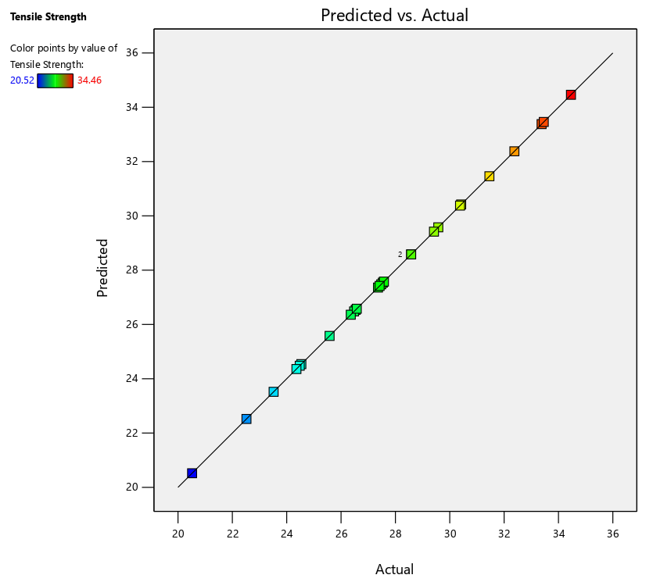

**FIGURE 3:** Predicted Vs Actual

The Figure 4 shows the response surfaces for the effect of infill % and speed on tensile strength for the box pattern. The tensile strength tends to increase steadily with an increase in infill % and speed. Increase in infill % results more material deposition and hence there is increase in the strength [1]. There is slight variation or increment in the strength due to increase in the speed.

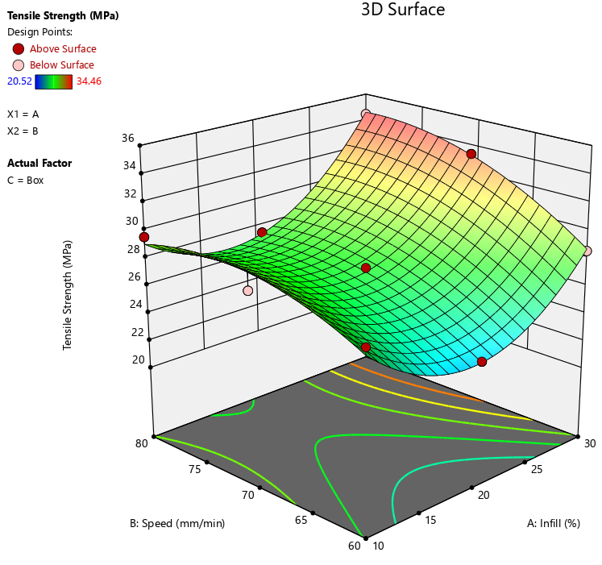

**FIGURE 4:** Effect of Infill% vs. Speed on Tensile Strength (Box Pattern, 3D Surface)

Figure 5 shows the estimated response surface for the hardness in relation to the individual parameters of the infill % and speed for the box section. The hardness reaches to the maximum value for the combination low infill % & high speed and high infill % & low speed. The hardness has its low value at high infill% & high speed and reaches its minimum at low infill%&low speed [3].

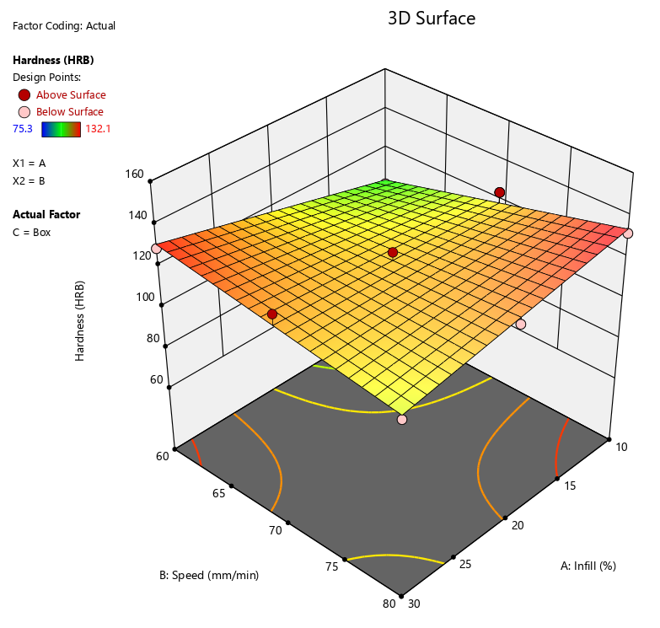

**FIGURE 5:** Effect of Infill% vs. Speed on Tensile Strength (Box Pattern, 3D Surface)

## CONCLUSION

The optimal combination of process parameters of FDM printing have been determined based on mechanical properties such as tensile and hardness of CF-PLA in this work. The Tensile Strength and hardness of the 0o orientation CF-PLA composite samples are 36 MPa and 1520 MPa respectively which are greater than PLA composite samples. The mechanical properties such as tensile and hardness of CF-PLA composites samples fabricated by 3D Printers have been evaluated. Identification of the influence of the operating parameters of 3D printing such as infill % and speed for the box pattern has been analyzed. The interaction effect of the factors has been obtained by solving the regression equation and the response surface plots. Among all 3D printed samples, the box section gives higher tensile strength and higher hardness values.

## REFERENCES

1. Zhaobing L, Qian L, Shuaiqi X, “Mechanical characteristics of wood, ceramic, Metal and carbon fiber-based PLA composites fabricated by FDM”, *Journal of Material Research and Technology (2019)*; 8(5),pp. 3741-3751.
2. Zengguang L, Yanqing W, Beicheng W, Chunzhi C, Yu G, Cheng Y, “[A critical review](http://refhub.elsevier.com/S2238-7854(19)30190-5/sbref0005) [of](http://refhub.elsevier.com/S2238-7854(19)30190-5/sbref0005) FDM [3D](http://refhub.elsevier.com/S2238-7854(19)30190-5/sbref0005) [printing](http://refhub.elsevier.com/S2238-7854(19)30190-5/sbref0005) [technology](http://refhub.elsevier.com/S2238-7854(19)30190-5/sbref0005) [in manufacturing](http://refhub.elsevier.com/S2238-7854(19)30190-5/sbref0005) PLA [parts”. *Int*](http://refhub.elsevier.com/S2238-7854(19)30190-5/sbref0005)*.* [*J AdvManufTechnol* (2019);102(9–12):2877–2889.](http://refhub.elsevier.com/S2238-7854(19)30190-5/sbref0005)
3. Xin [Wang](http://refhub.elsevier.com/S2238-7854(19)30190-5/sbref0010),Man [Jiang](http://refhub.elsevier.com/S2238-7854(19)30190-5/sbref0010), Zuowan[,](http://refhub.elsevier.com/S2238-7854(19)30190-5/sbref0010) Jihua G, David H, “[3D](http://refhub.elsevier.com/S2238-7854(19)30190-5/sbref0010) [printing](http://refhub.elsevier.com/S2238-7854(19)30190-5/sbref0010) [of](http://refhub.elsevier.com/S2238-7854(19)30190-5/sbref0010) [polymer matrix](http://refhub.elsevier.com/S2238-7854(19)30190-5/sbref0010) [composites: are](http://refhub.elsevier.com/S2238-7854(19)30190-5/sbref0010) [view and perspective](http://refhub.elsevier.com/S2238-7854(19)30190-5/sbref0010)”[, *Composite Part*](http://refhub.elsevier.com/S2238-7854(19)30190-5/sbref0010)[*B (2017)* ;110:pp. 442–458.](http://refhub.elsevier.com/S2238-7854(19)30190-5/sbref0010)
4. Javeed S M[.](http://refhub.elsevier.com/S2238-7854(19)30190-5/sbref0015) “[Applications of 3D printing technologies in oceanography](http://refhub.elsevier.com/S2238-7854(19)30190-5/sbref0015)”[*, Methods*](http://refhub.elsevier.com/S2238-7854(19)30190-5/sbref0015) *in* [*Oceanogr*](http://refhub.elsevier.com/S2238-7854(19)30190-5/sbref0015)*aphy*  (2016) [;17:pp.97–117.](http://refhub.elsevier.com/S2238-7854(19)30190-5/sbref0015)
5. Mary K T, Giovanni M, Tom V, Georges F, “[Design](http://refhub.elsevier.com/S2238-7854(19)30190-5/sbref0020) [for additive manufacturing:](http://refhub.elsevier.com/S2238-7854(19)30190-5/sbref0020) [trends,](http://refhub.elsevier.com/S2238-7854(19)30190-5/sbref0020) [opportunities, considerations, and constraints”,](http://refhub.elsevier.com/S2238-7854(19)30190-5/sbref0020) [*CIRP*](http://refhub.elsevier.com/S2238-7854(19)30190-5/sbref0020)[*Adv ManufTechnol*](http://refhub.elsevier.com/S2238-7854(19)30190-5/sbref0020) (2016)[;65:pp.737–760.](http://refhub.elsevier.com/S2238-7854(19)30190-5/sbref0020)
6. Vladimir E. K, Alexey N, Oleg D. U, Richard S and Azamat G. T, “[Strength of PLA](http://refhub.elsevier.com/S2238-7854(19)30190-5/sbref0025) [components fabricated with fused deposition technology using a desktop3D printer as a](http://refhub.elsevier.com/S2238-7854(19)30190-5/sbref0025) [function of geometrical parameters of the process”. *Polymers*](http://refhub.elsevier.com/S2238-7854(19)30190-5/sbref0025) (2018)[;10(3):pp.313.](http://refhub.elsevier.com/S2238-7854(19)30190-5/sbref0025)
7. [Song Y, Li Y, Song W, Yee K, Lee KY, Tagarielli](http://refhub.elsevier.com/S2238-7854(19)30190-5/sbref0030) [VL. “Measurements of the mechanical response of unidirectional3D-printed PLA”. *Materials*](http://refhub.elsevier.com/S2238-7854(19)30190-5/sbref0030) *and* [*Des*](http://refhub.elsevier.com/S2238-7854(19)30190-5/sbref0030)*ign (2018)*[; 123:pp.154–164.](http://refhub.elsevier.com/S2238-7854(19)30190-5/sbref0030)
8. [John](http://refhub.elsevier.com/S2238-7854(19)30190-5/sbref0035) [RCD,](http://refhub.elsevier.com/S2238-7854(19)30190-5/sbref0035) [Alejandro](http://refhub.elsevier.com/S2238-7854(19)30190-5/sbref0035) [H,](http://refhub.elsevier.com/S2238-7854(19)30190-5/sbref0035) [Espera](http://refhub.elsevier.com/S2238-7854(19)30190-5/sbref0035) [JR ,Chen](http://refhub.elsevier.com/S2238-7854(19)30190-5/sbref0035) [QY,](http://refhub.elsevier.com/S2238-7854(19)30190-5/sbref0035) [Rigoberto](http://refhub.elsevier.com/S2238-7854(19)30190-5/sbref0035) [CA](http://refhub.elsevier.com/S2238-7854(19)30190-5/sbref0035). [“Mechanical characterization of 3D-printed polymers”. *Addit*](http://refhub.elsevier.com/S2238-7854(19)30190-5/sbref0035)*ive* [*Manuf*](http://refhub.elsevier.com/S2238-7854(19)30190-5/sbref0035)*acturing* (2018); [20:pp.44–67.](http://refhub.elsevier.com/S2238-7854(19)30190-5/sbref0035)
9. David B, Jean PK , Ming L, Gideon L, David R , Allison M, Beese, Adam C, “[Materials for additive manufacturing”. *CIRP Annals—Manuf*](http://refhub.elsevier.com/S2238-7854(19)30190-5/sbref0040)*acturing* [*Technol*](http://refhub.elsevier.com/S2238-7854(19)30190-5/sbref0040)*ogy (2018)*[,66:pp.659–681.](http://refhub.elsevier.com/S2238-7854(19)30190-5/sbref0040)
10. [Shilpesh](http://refhub.elsevier.com/S2238-7854(19)30190-5/sbref0060) [RR, Harshit](http://refhub.elsevier.com/S2238-7854(19)30190-5/sbref0060) [KD*.*](http://refhub.elsevier.com/S2238-7854(19)30190-5/sbref0060) “[Effect of process parameters on tensile](http://refhub.elsevier.com/S2238-7854(19)30190-5/sbref0060) [strength](http://refhub.elsevier.com/S2238-7854(19)30190-5/sbref0060) [of](http://refhub.elsevier.com/S2238-7854(19)30190-5/sbref0060) [FDM](http://refhub.elsevier.com/S2238-7854(19)30190-5/sbref0060) [printed](http://refhub.elsevier.com/S2238-7854(19)30190-5/sbref0060) [PLA](http://refhub.elsevier.com/S2238-7854(19)30190-5/sbref0060) [part”,](http://refhub.elsevier.com/S2238-7854(19)30190-5/sbref0060)[*Rapid*](http://refhub.elsevier.com/S2238-7854(19)30190-5/sbref0060)[*Prototyp*](http://refhub.elsevier.com/S2238-7854(19)30190-5/sbref0060)*ing* [*J*](http://refhub.elsevier.com/S2238-7854(19)30190-5/sbref0060)*ournal (2018)*;[24(8):pp.1317–1324.](http://refhub.elsevier.com/S2238-7854(19)30190-5/sbref0060)
11. Saurabh [C,](http://refhub.elsevier.com/S2238-7854(19)30190-5/sbref0080) Inderdeep [Singh,](http://refhub.elsevier.com/S2238-7854(19)30190-5/sbref0080) “[Eco-friendly treatment of aloevera fibers](http://refhub.elsevier.com/S2238-7854(19)30190-5/sbref0080) [for](http://refhub.elsevier.com/S2238-7854(19)30190-5/sbref0080) [PLA](http://refhub.elsevier.com/S2238-7854(19)30190-5/sbref0080) [based](http://refhub.elsevier.com/S2238-7854(19)30190-5/sbref0080) [green](http://refhub.elsevier.com/S2238-7854(19)30190-5/sbref0080) [composites” .*Int*](http://refhub.elsevier.com/S2238-7854(19)30190-5/sbref0080)*.* [*JPrecis*](http://refhub.elsevier.com/S2238-7854(19)30190-5/sbref0080)*ion* [*Eng*](http://refhub.elsevier.com/S2238-7854(19)30190-5/sbref0080)*ineering* [*Manuf*](http://refhub.elsevier.com/S2238-7854(19)30190-5/sbref0080)*acturing* [*Technol*](http://refhub.elsevier.com/S2238-7854(19)30190-5/sbref0080)*ogy* (2018)[;5(1):pp.143–150.](http://refhub.elsevier.com/S2238-7854(19)30190-5/sbref0080)
12. Chacón, J. M., Caminero, M. A., Núñez, P. J., García-Plaza, E., García-Moreno, I., & Reverte, J. M, “Additive manufacturing of continuous fibre reinforced thermoplastic composites using FDM”; Effect *of process parameters on mechanical properties, Composites Science and Technology (2019)*; 181,pp. 1076-1088.
13. Kovan, V., Tezel, T., Camurlu, H. E., &Topal, E. S, Effect of printing parameters on mechanical properties of 3d printed PLA / carbon fibre composites (2018); 128(4),pp.126–128.